**Final Project**

For your final project you will develop a multi-page website that uses HTML/CSS along with JavaScript functionality. The website will be about AUM’s computer science department, and will be structured in the following way:

1. **Home.html**

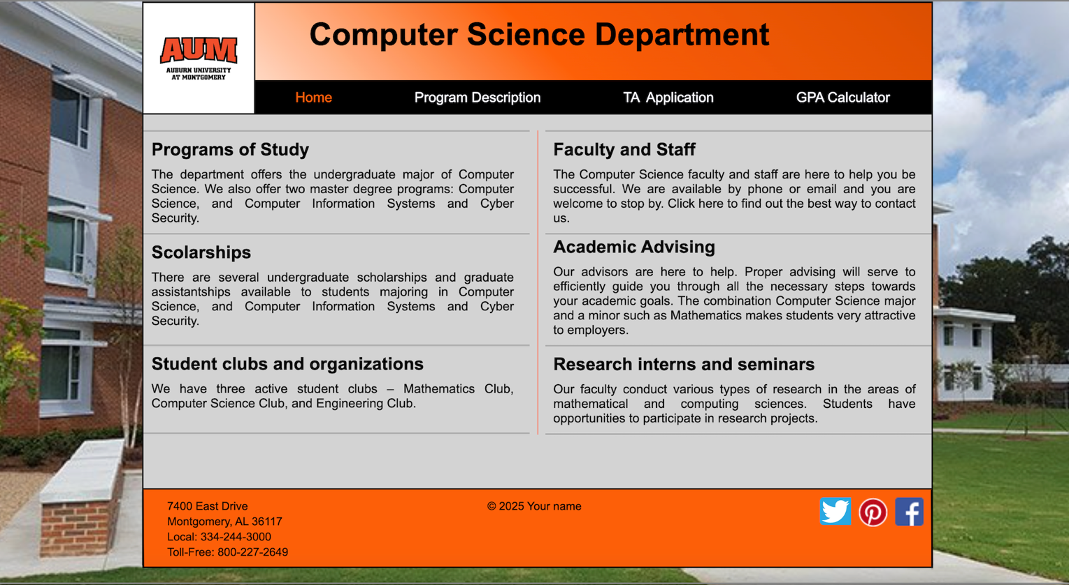

**Requirements:**

-Apply all the needed CSS formatting to make it look as close as possible to the example image.

-The “Home” element of the navigation menu of the header must be orange since it is the current page.

- Regarding the navigation menu of the header, all elements must have working links, where clicking on Home -> home.html, Program Description -> description.html, TA Application -> TA.html, GPA Calculator -> GPA.html. Make sure to implement this requirement in all html files.

-Hovering the cursor on any of the navigation menu elements of the header must change their background color to gray. Make sure to implement this requirement in all html files.

-Use gradient colors for the Header of the page

-Write your own name in the middle part of the Footer

1. **Description.html**

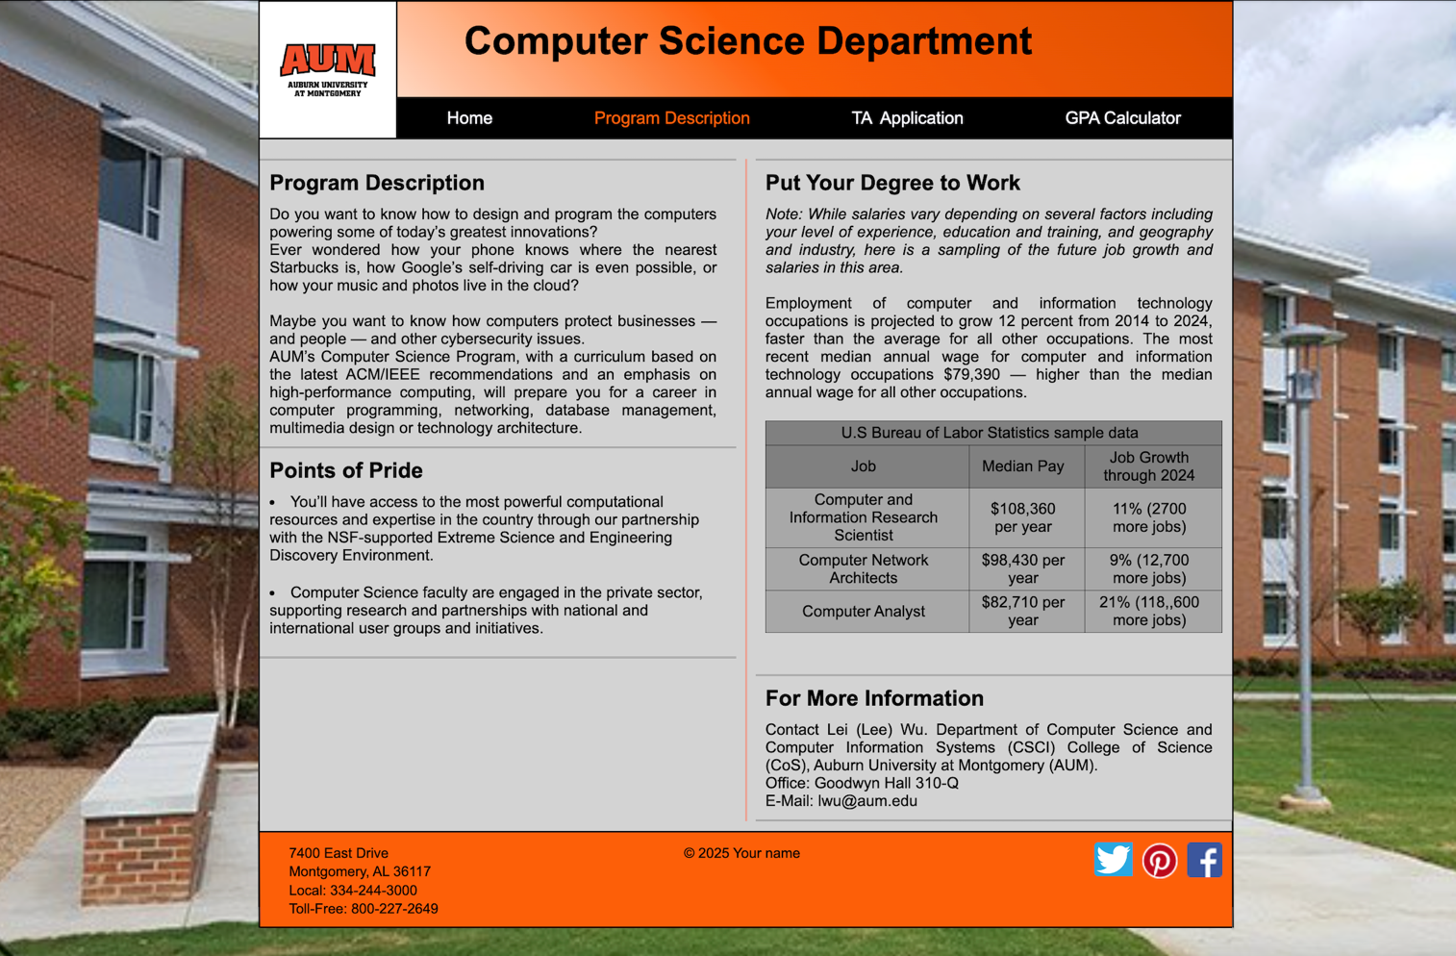

**Requirements:**

-The “Program Description” element of the navigation menu of the header must be orange since it is the current page.

-Make sure to format the unordered list and table the same way as the example image.

1. **TA.html**

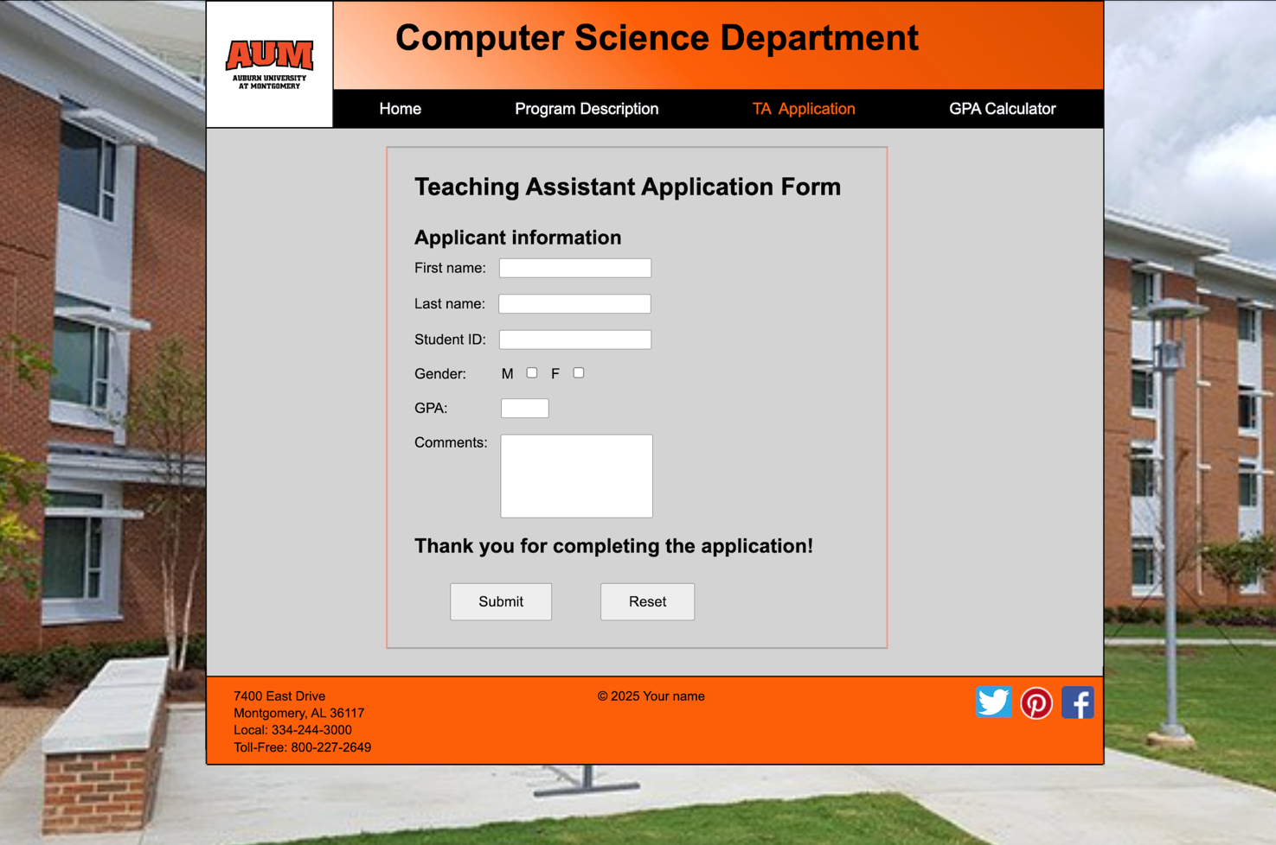

**Requirements:**

-The “TA Application” element of the navigation menu of the header must be orange since it is the current page.

-For the TA application form, all inputs must be required except Comments, which is optional

-Use text box inputs for First Name, Last Name, Student ID, GPA, and Comments. Use a checkbox input for the Gender. Make sure to format them with the same sizes as the example image

-When clicking on the Submit button, the website should be re-directed to survey_data.html where all the data from the form should display accurately.

-When clicking on Reset button, all input boxes should be clear of any data.

1. **GPA.html**

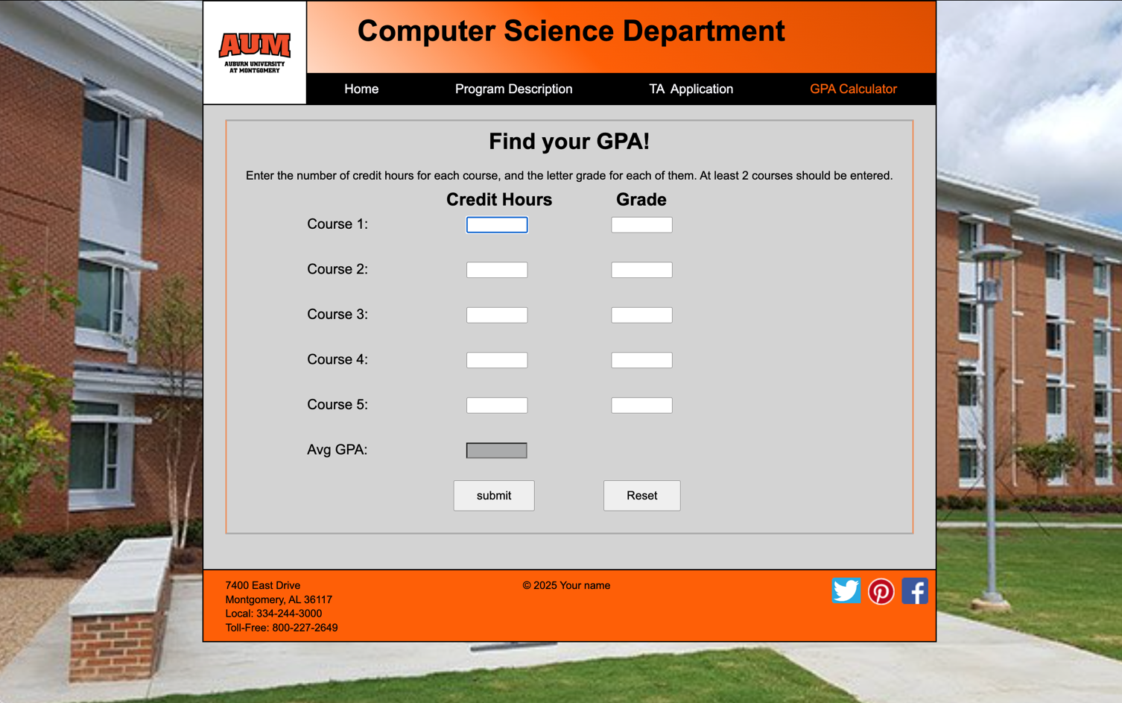

**Requirements:**

-The “GPA Calculator” element of the navigation menu of the header must be orange since it is the current page.

- The GPA Calculator won’t be a form, instead it will consist of text boxes that will be controlled by a JavaScript file called: **GPA.js**

-On the JavaScript file, create an event that allows the first input box to be focused when the page loads.

-On the JavaScript file, create a function that gets the element values from the input text boxes if the user clicks on the Submit button, and calculates the average GPA result to display. Keep in mind that the inputs will be received as letters, with the corresponding amount of credit hours as numbers. Then, call the function it with an onclick event.

-Create a function that sets all the input boxes to empty values if the user clicks the Reset button. Then, call it with an onclick event.

-The GPA calculator must require at least a minimum of 2 entries for Grade and Credit Hours, up to 5 entries max.

-The formula to obtain the average GPA is: 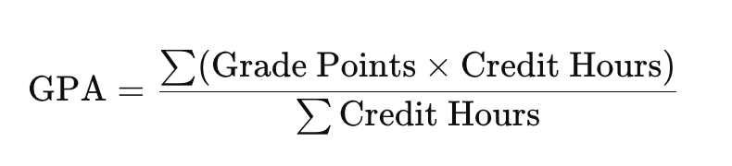

Note: Σ -> “sum of all entries”

-The GPA result should always display with a maximum of 2 decimal places

-In order to check if your calculator is working correctly, test with the following examples:

Example 1

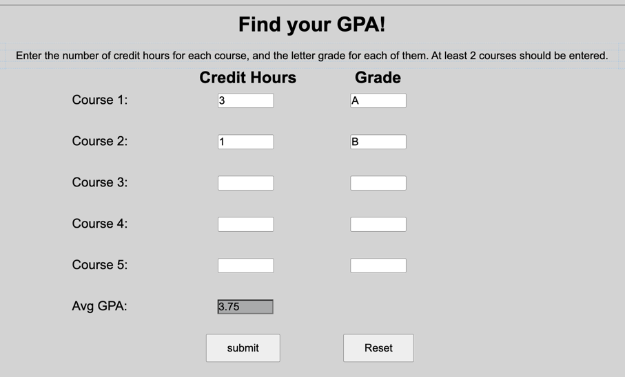

Example 2

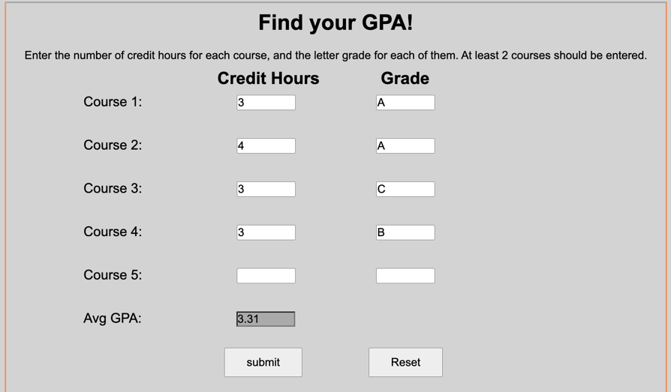

Example 3:

